Computer Networks
HOMEWORK #5
Due date: 2025-06-01
NOTE: WRITE YOUR ANSWERS IN ENGLISH.
ID#:2022310865 Name: (Kor.)배민수 (Eng.)Minsoo Bae

Problem #1. (10pts) Consider a connection from Earth to Mars. The distance from Earth to Mars is about 36 million miles in the best case (the exact distance depends on the relative orbital positions of the two planets and can be much more). Assume a link rate of 1 Mb/s, a packet length of 1500 bytes, and a light propagation rate is 0.2 miles/microsecond.
- What window size (in bytes) would a TCP connection need to maintain 100% throughput for the connection?
First calculate the one-way propagation delay:
$$d_{prop}=\frac{36,000,000}{0.2}=180,000,000 μs \\ 180,000,000 μs=180 s$$
Round-trip time (RTT):
$$RTT=2×180=360 s$$
To fully utilize the link:
$$Window=Bandwidth×RTT \\ Window={10}^{6}×360=360,000,000 bits$$
Convert to bytes:
$$\frac{360,000,000}{8}=45,000,000 bytes$$

Answer
$$45,000,000 bytes$$
- Can the window size you computed be used with the current TCP standard? Explain your answer.

Traditional TCP uses a 16-bit receive window field.
Maximum window:
$$2^{16}-1=65,535 bytes$$
Required window:
$$45,000,000 bytes$$
Since
$$45,000,000>65,535$$
the standard TCP window field is insufficient.
However, modern TCP supports the Window Scale Option (RFC 7323), which allows much larger windows.

Answer
No, the original TCP standard cannot support a 45,000,000-byte window because its maximum window size is only 65,535 bytes. Modern TCP can support it using the Window Scale Option.

Problem #2. (10pts) Suppose two packets arrive to two different input ports of a router at exactly the same time. Also, suppose there are no other packets anywhere in the router.
- Suppose the two packets are to be forwarded to two different output ports. Is it possible to forward the two packets through the switch fabric at the same time when the fabric uses a shared bus? Explain your answer.
A shared-bus switch has only one bus. Only one packet can use the bus at a time.
Therefore, even if the packets are going to different output ports, they cannot cross the bus simultaneously.
Answer
No. A shared-bus architecture allows only one packet to use the bus at a time, so the packets must be forwarded sequentially.

- Suppose the two packets are to be forwarded to two different output ports. Is it possible to forward the two packets through the switch fabric at the same time when the fabric uses switching via memory? Explain your answer
With memory-based switching:
- Packet 1 is copied into memory.
- Packet 2 is copied into memory.
- The CPU moves packets from memory to output ports.
Since memory access is shared, packets cannot be switched simultaneously.
Answer
No. Memory-based switching requires shared memory access, so packets are processed one after another rather than simultaneously.

- Suppose the two packets are to be forwarded to the same output port. Is it possible to forward the two packets through the switch fabric at the same time when the fabric uses a crossbar? Explain your answer
A crossbar allows multiple simultaneous transfers only if they use different outputs.
Here both packets want the same output port.
The output port can accept only one packet at a time.
Answer
No. Even with a crossbar switch, two packets destined for the same output port cannot be forwarded simultaneously because the output port becomes the bottleneck.

Problem #3. (10pts) A student is sending a 5,000,000-byte MP3 file from Host A to Host B over the Internet. Along the path, each IP datagram is limited to 1,500 bytes, including headers. Assume the following:
- IP header size = 20 bytes
- TCP header size = 20 bytes
- Each IP datagram carries one TCP segment
- Ignore any other protocol overhead
How many IP datagrams are required to transmit the entire MP3 file? Show your calculation and explain your answer.

Step 1: TCP payload per datagram
Available application data: $1500-20-20=1460 bytes$
Each IP datagram carries: $1460 bytes$of MP3 data.

Step 2: Number of datagrams
$$\frac{5,000,000}{1460}=3424.6575$$
Round up: $\boxed{3425}$
Answer
Each IP datagram can carry 1460 bytes of MP3 data.
$$\text{Number of datagrams}=\left\lceil \frac{5,000,000}{1460}\right\rceil =3425$$
Therefore,
$$3425\text{ IP datagrams}$$
are required.

Problem #4. (20pts) A university is building a small experimental campus network. The network administrator is given an 8-bit IPv4-like address space, which means there are 2⁸=256 possible addresses. The university wants to divide this address space equally among eight departments, named N0 to N7. All department networks are connected through one central router. The router has eight interfaces, named m0 to m7, where each interface connects to one department network.
Your task is to design the addressing plan and the forwarding table for the central router.
- (4pts) How many addresses should be assigned to each department network?

Total address space: $2^{8}=256$
Departments: $8$
Addresses per department:
$$\frac{256}{8}=32$$
Answer: $\boxed{32 addresses}$
- (4pts) What is the prefix length for each department network?
32 addresses means: $32=2^{5}$
Host bits = 5
Therefore: $8-5=3$
Answer: $\boxed{/3}$
- (6pts) Assign an address range and network address to each department network N0 to N7.
Department | Network Address | Address Range
N0 | 0 | 0–31
N1 | 32 | 32–63
N2 | 64 | 64–95
N3 | 96 | 96–127
N4 | 128 | 128–159
N5 | 160 | 160–191
N6 | 192 | 192–223
N7 | 224 | 224–255

- (6pts) Construct the forwarding table of the central router. The table should include network prefix in binary and outgoing interface number
Network Prefix | Interface
000xxxxx | m0
001xxxxx | m1
010xxxxx | m2
011xxxxx | m3
100xxxxx | m4
101xxxxx | m5
110xxxxx | m6
111xxxxx | m7

Problem #5. (20pts) A company has a border router that connects several internal subnets and external networks. The router uses CIDR-based routing entries to decide where each incoming packet should be forwarded. The routing table of the router is shown below:
Address/mask | Next hop
128.114.56.0/22 | Interface 0
128.114.60.0/22 | Interface 1
192.168.30/23 | Router 1
Default | Router 2
For packets with the following IP addresses, show where the router will send the packet
(a) 128.114.63.09
(b) 128.114.57.11
(c) 128.114.52.02
(d) 192.168.33.05
(e) 192.168.31.06
IP Address | Destination
(a) 128.114.63.09 | Interface 1
(b) 128.114.57.11 | Interface 0
(c) 128.114.52.02 | Router 2 (Default)
(d) 192.168.33.05 | Router 2 (Default)
(e) 192.168.31.06 | Router 1

Problem # 6. (30pts) Final Web-based Network Application with Chat, File Transfer, Video Streaming, Ollama, and External APIs Integration
In this problem, you will develop a final integrated web-based network application based on the concepts practiced in previous homeworks. HW1 implemented TCP/UDP client-server communication, HW2 focused on authenticated multi-client chatting, and HW4 implemented video streaming. In HW5, you will integrate these ideas into one messenger-style web application.
The goal of this homework is to practice building a complete application-layer network system using HTTP, WebSocket, database storage, file transfer, external APIs, and local LLM APIs. Your application should provide the following major functions:
- user authentication,
- real-time user-to-user chatting,
- file upload and download through chat,
- an Ollama-based AI assistant,
- weather information using an external API,
- and a server-provided video streaming room.
The application does not need to use webcam streaming, live camera input, WebRTC, or real-time video broadcasting. The video streaming room only needs to serve a prepared video file, such as sample.mp4, from the server.
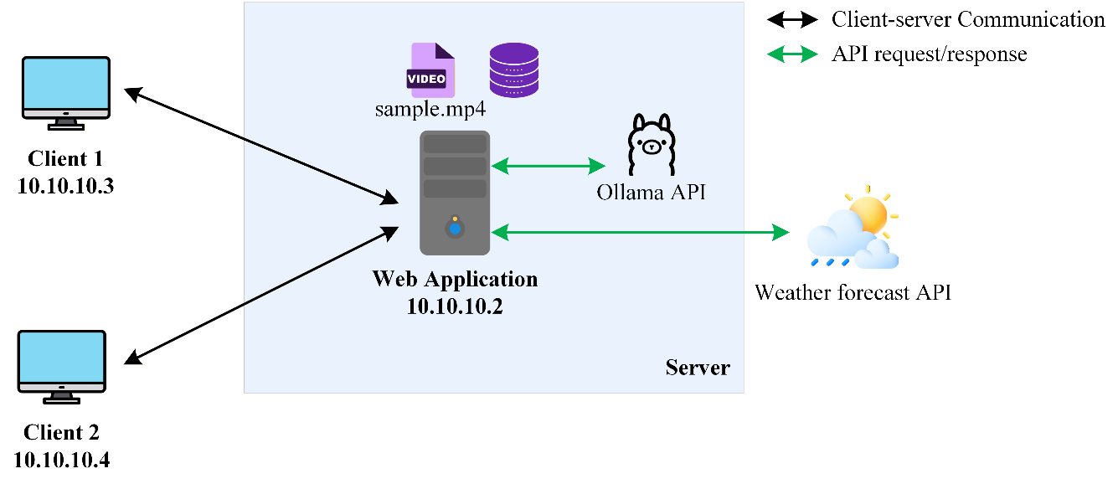
Figure 1. Messenger-style web application integrating chat, file transfer, video streaming, local LLM, and external API services.
Functional Requirements
Implement a web-based messenger application with the following functions:
- User authentication
- Users must be able to sign up, log in, and log out.
- User information must be stored in a SQLite database.
- Passwords must be stored as hashes, not as plain-text passwords.
- The server must manage user sessions after login.
- Messenger-style user list
- The application must show all registered users.
- Online users must be marked with a green status indicator.
- Offline users must be marked with a gray status indicator.
- The user list should be updated when users log in or log out.
- Real-time chat
- Users must be able to select another user and exchange messages.
- Messages should be delivered in real time when both users are online.
- WebSocket or an equivalent real-time communication mechanism should be used.
- Chat history must be stored in the SQLite database.
- When a user opens a previous conversation, the stored chat history should be displayed.
- File transfer
- Users must be able to attach and send files through the chat interface.
- Uploaded files must be saved on the server.
- File information should be stored in the database.
- The receiver should be able to download the file from the chat interface.
- The report should include screenshots showing both file upload and file download.
- Video streaming room
- The application must include a video streaming page or room.
- The server should provide a prepared video file, such as sample.mp4.
- Multiple users should be able to open the streaming room and watch the server-provided video.
- You do not need to implement webcam streaming, live camera streaming, WebRTC, or real-time video broadcasting.
- The video file should not be included in the submitted source code if it is large. Instead, explain where the video file should be placed and how it should be named.
- Ollama AI assistant
- The application must include an AI assistant contact, such as Ollama.
- This AI assistant should always appear online in the user list.
- When the user chats with this contact, the server should send the user’s message to the local Ollama API.
- The generated response from Ollama should be returned and displayed in the chat interface.
- Streaming token-by-token output is not required.
- You may use any installed Ollama model, but llama3.2:3b is recommended.
- External weather API
- The application must use at least one external weather API.
- Today’s weather information should be displayed in the web interface, for example in the top-right corner of the messenger page.
- It is acceptable to use a fixed city, such as Seoul, or to allow the user to enter a city.
- The browser should request weather information from your server.
- Your server should then call the external weather API and return the result to the browser.
- The browser should not directly call the external weather API.
Demo:
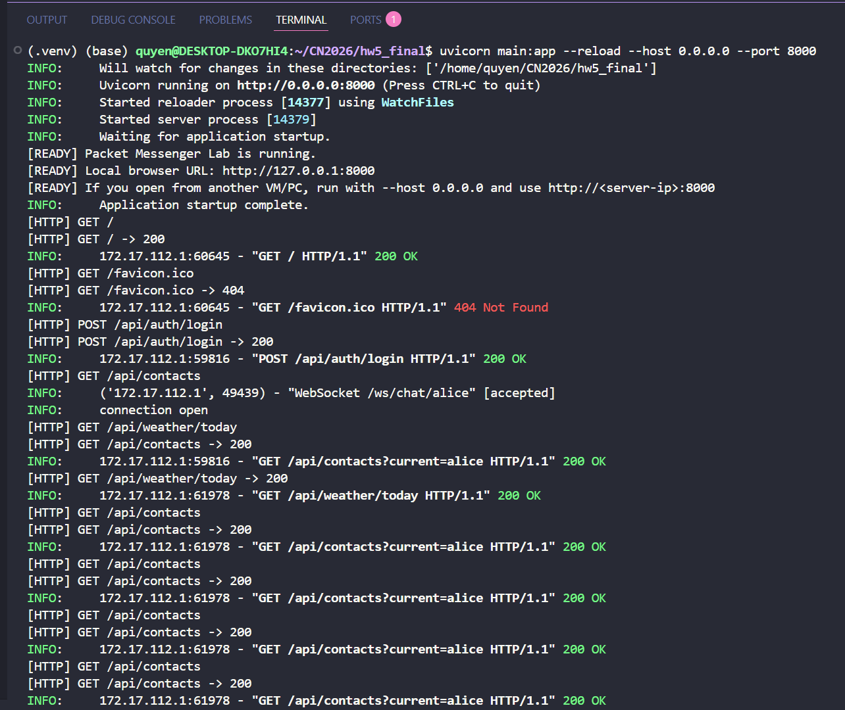
Figure 2. Server terminal while running the application
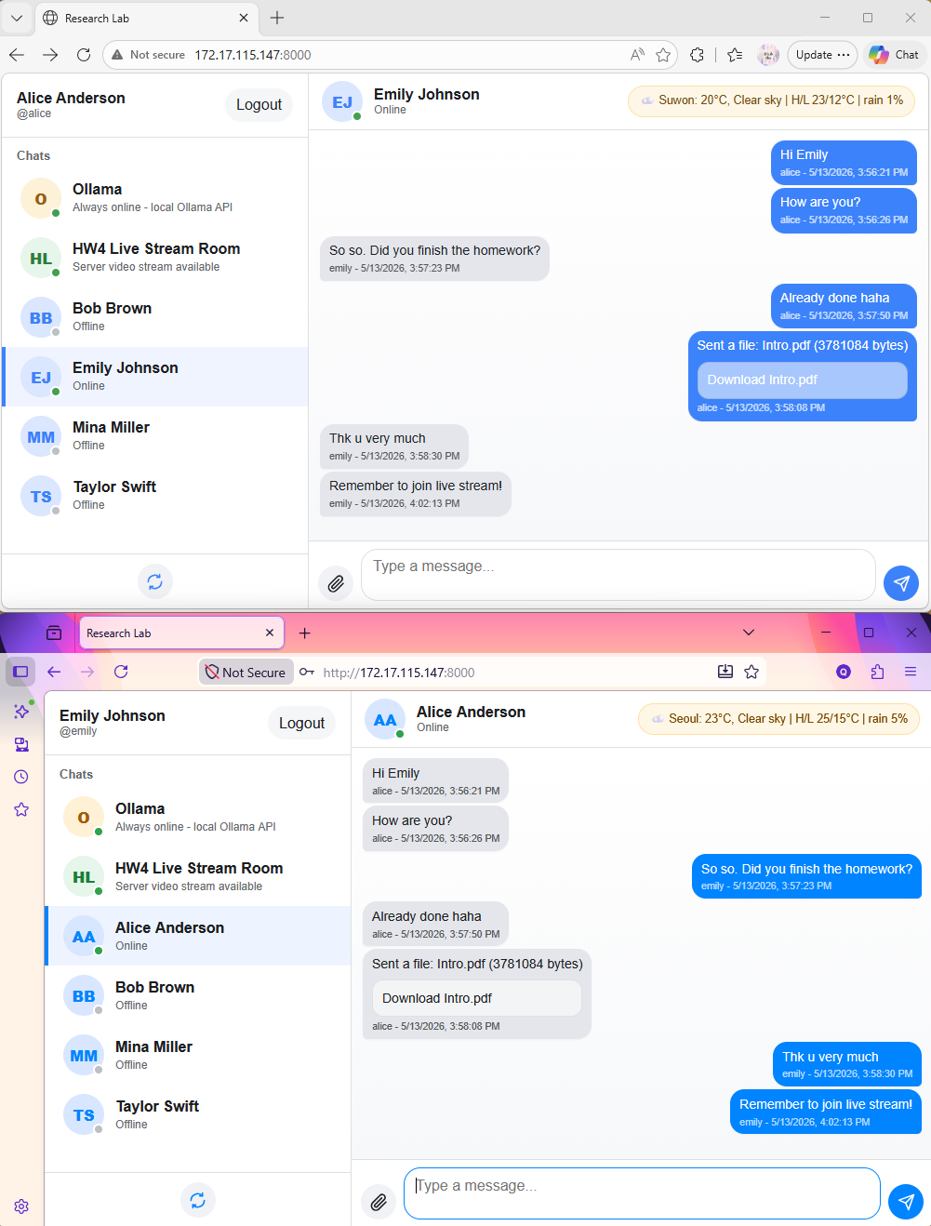
File upload/download
Weather information in the UI
Online/offline user list
Figure 3. End-to-end chat
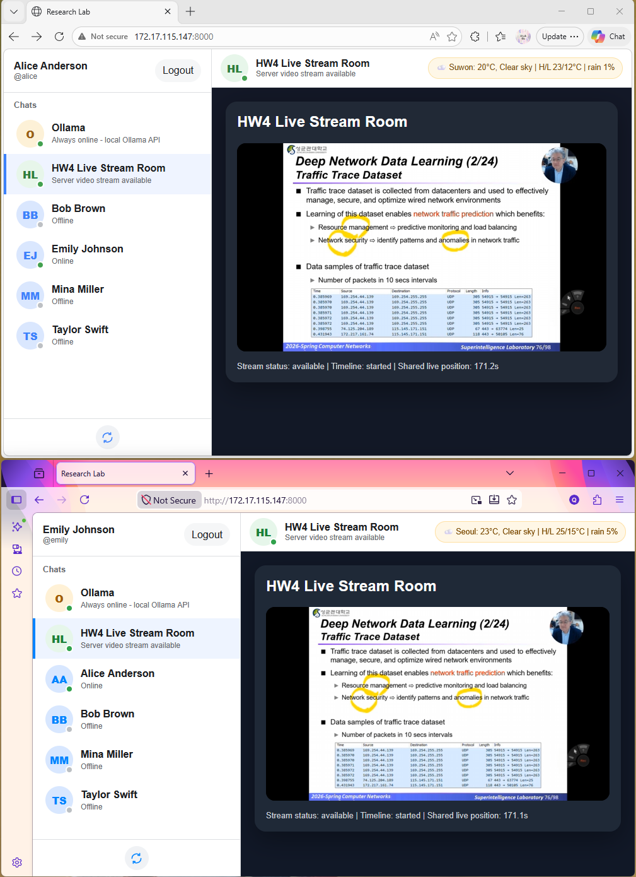
Figure 4. Video streaming room
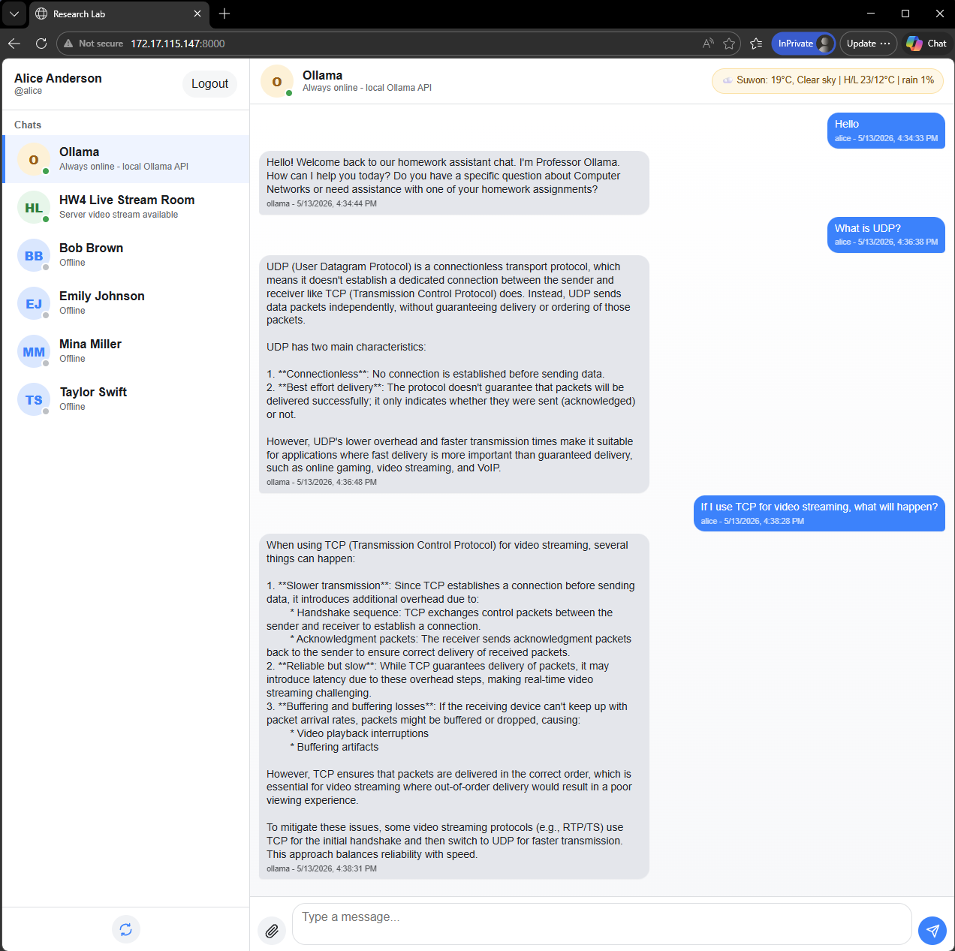
Figure 5. Chat with Ollama
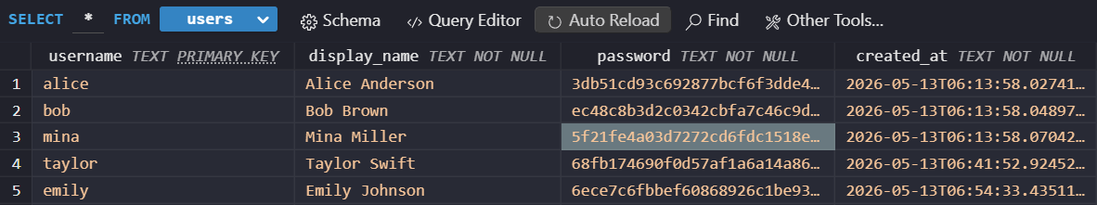
Figure 6. SQLite user table
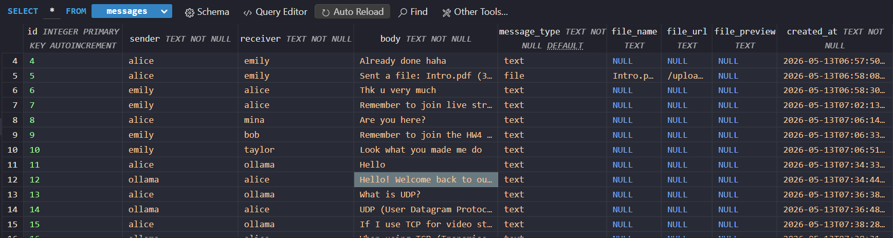
Figure 7. SQLite message or file table
Implementation requirements:
Your program must satisfy the following requirements:
- The project must be implemented as a web application.
- The server must support sign up, login, logout, and user session management.
- The server must use SQLite for user accounts and chat records, and file records.
- The web interface must show registered users and their online/offline status.
- The system must support real-time user-to-user chatting.
- The system must support file upload and download.
- The system must include an Ollama AI assistant as a special chat contact.
- The system must use at least one external weather API.
- The system must include a video streaming page or room.
- The report must explain how this final project integrates concepts from HW1, HW2, and HW4.
Hints:
You may use any programming language and framework. The following simple stack is recommended:
- Backend: Python + FastAPI + Uvicorn or another framework
- Frontend: HTML + CSS + JavaScript
- Database: SQLite3
- Real-time chat: WebSocket
- AI assistant: Ollama local API (Ref: Install Ollama, Ollama API, model llama3.2:3b)
- Weather API: Open-Meteo or another public weather API (Ref: Free Weather API)
- Video streaming: Prepared MP4 file served by the web server (Do not include it in the source code).
What to hand in:
- Screenshots: Include screenshots in your report showing all the implemeted functions. Screenshots must demonstrate multiple clients running simultaneously.
- Your implemented source codes (Attach your source code, database files).
- The command line: Provide clear instructions on HOW TO RUN your applications, either in the report or as comments in your code. Specify the exact commands for each component.
--------------------------------------------------------------------------------------------------------
Submission guidelines:
- You must submit a compressed file named CN26-HW5-ID-NAME.zip through i-Campus.
For example: CN26-HW5-2024970211-Park Chaeyoung.zip where 2024970211 is student ID and Park Chaeyoung is student NAME
- Your solution must be written in ENGLISH. Solution written in Korean will NOT be graded.
- You must use the .doc template provided on i-Campus.
There will be serious penalty for students who copy each other.

Screenshots
- User authentication
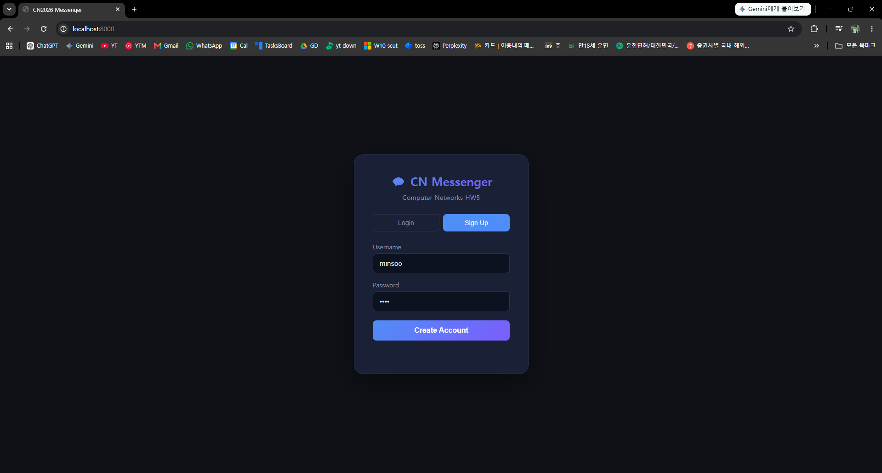
Figure 1. Signup page
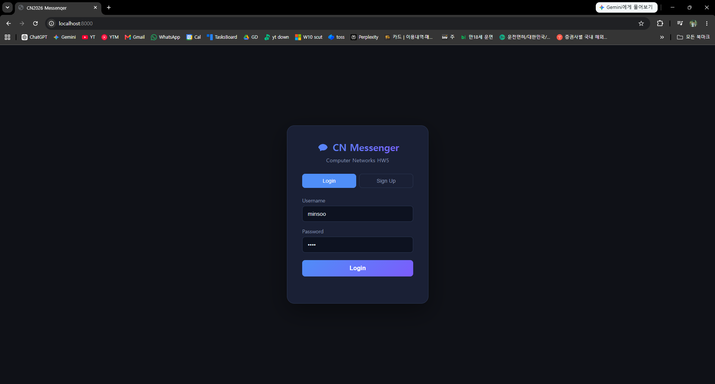
Figure 2. Login page

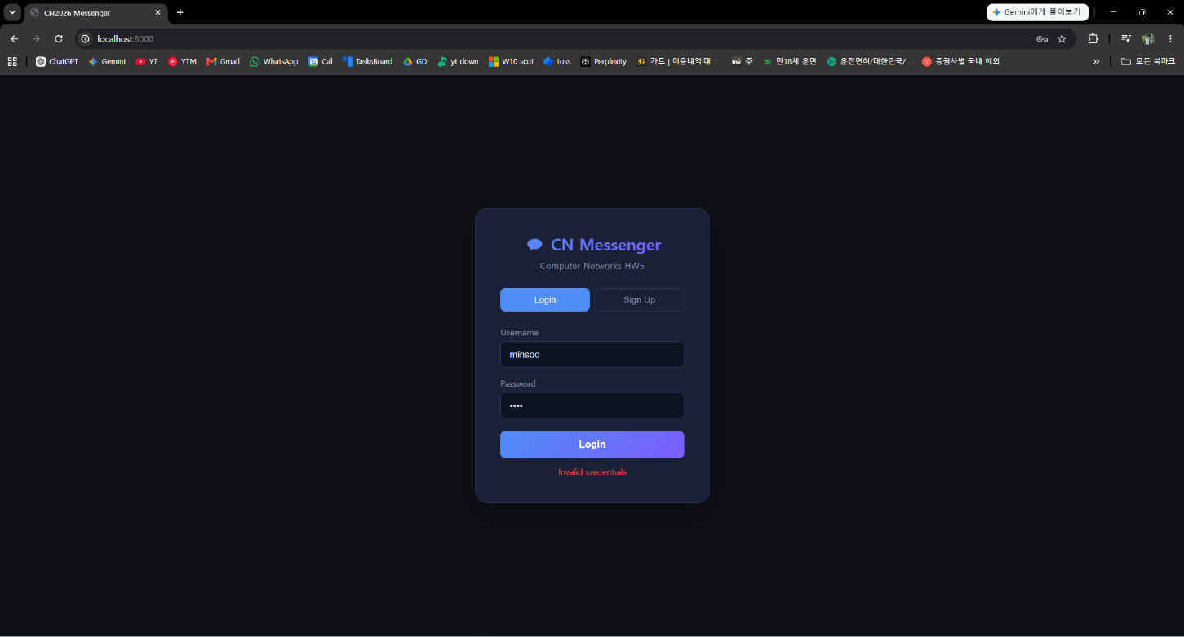
Figure 3. Login error: “Invalid credentials”

- Messenger-style user list
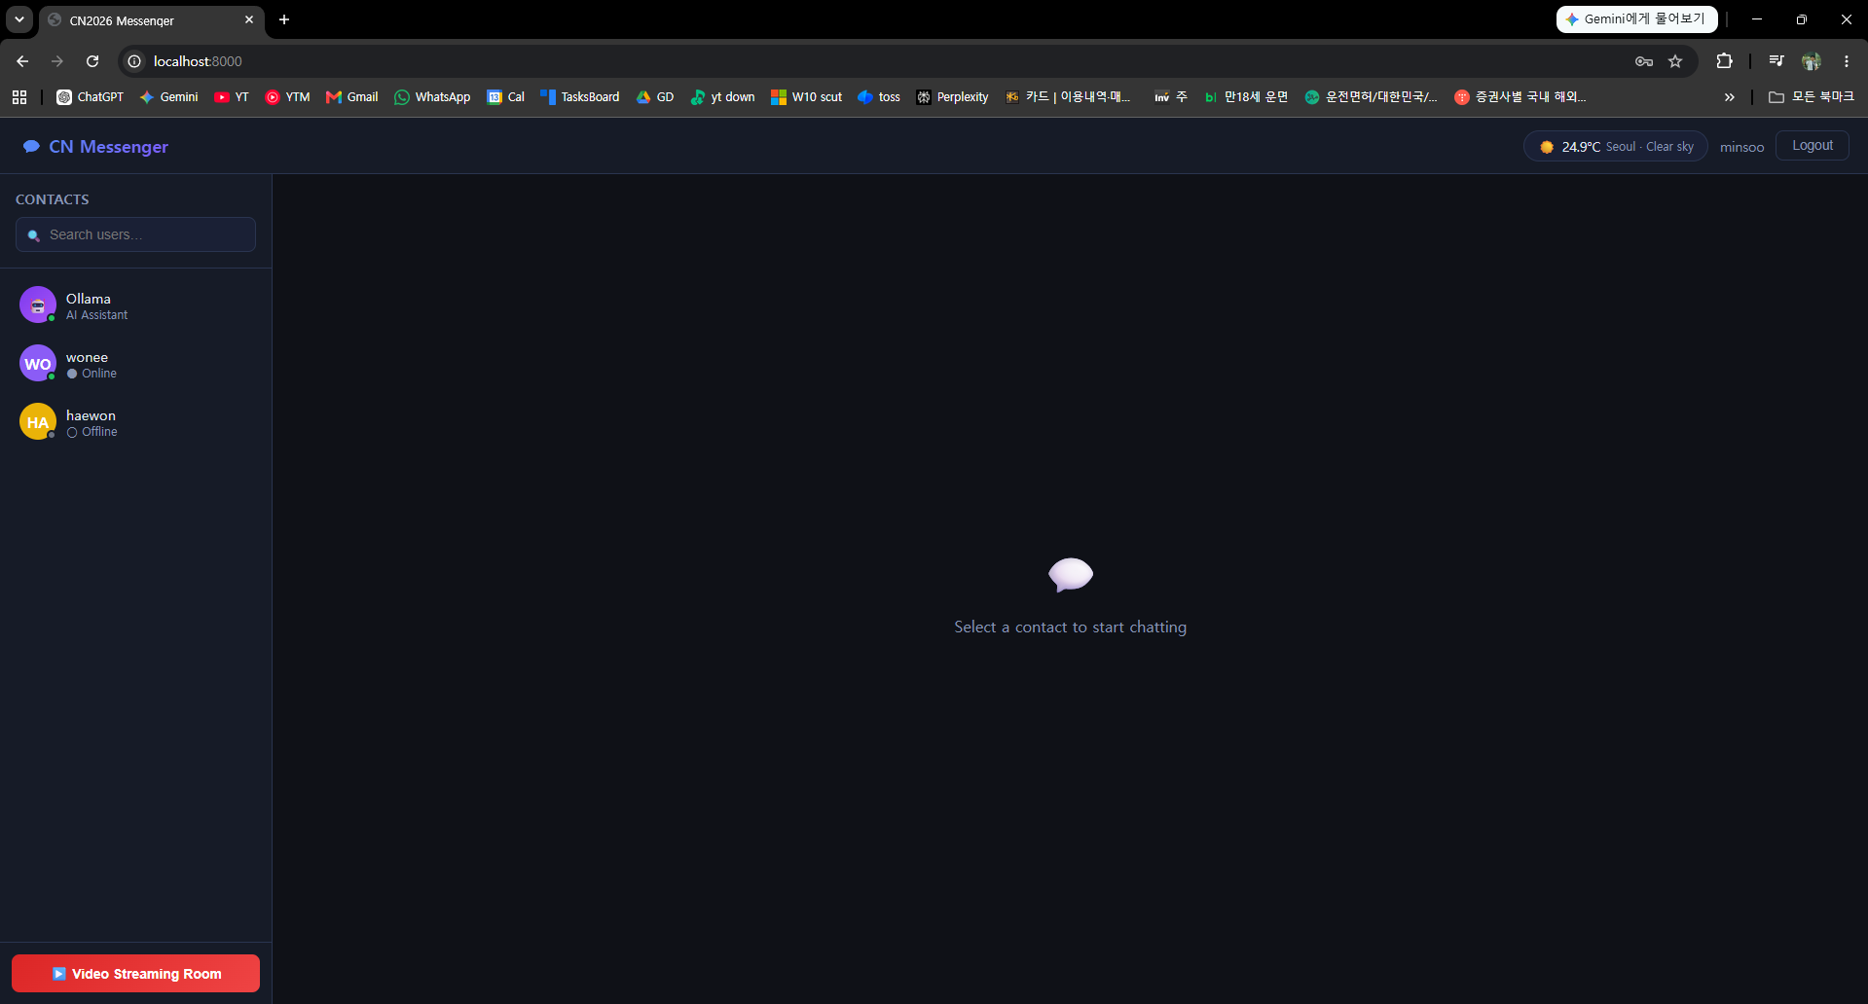
Figure 4. User list from minsoo’s account

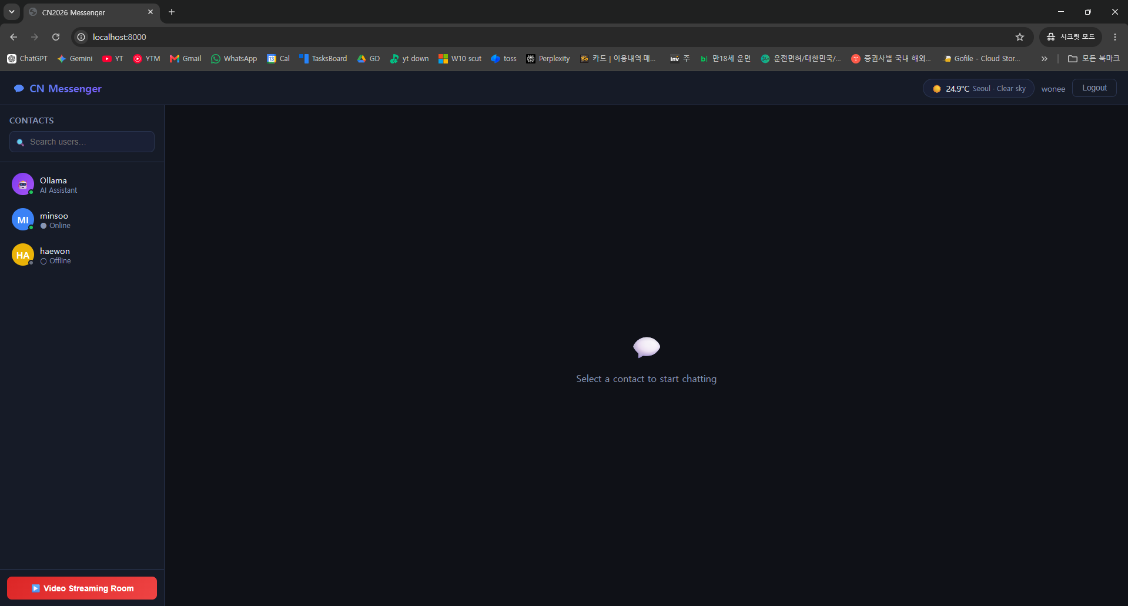
Figure 5. User list from wonee’s account

Both Figure 4 and Figure 5 shows all registered users.
Online users are marked with a green status indicator and Offline users marked with gray.
The user list is also updated when users log in or log out.

- Real-time chat

- File transfer

- Video streaming room

- Ollama AI assistant

- External weather API

